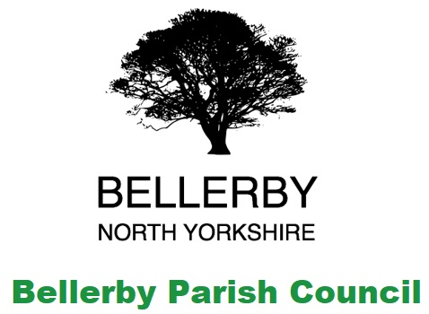**Bellerby Parish Council**

Site Meeting at Bellerby Community Garden DL8 5QN

**Friday 10th June 2022 at 7:00 pm**

The meeting was attended by:

The clerk Lynn Watkinson.

Councillors Singleton & Hutchinson

4 members of the proposed steering committee were present

2 members of the public were also present

**Business Matters**

1. Update on funding applications submitted

The application for donation of materials from Wickes is outstanding.

A funding application to Broadacres has been approved with £500 available for the purchase of Fruit Trees and Bushes.

1. Design

Cllr Hutchinson agreed to draw up a number of design ideas for discussion at the next meeting.

1. Open Gardens event 3rd July 2022

The event and the children’s competition to be hosted at the Garden have been advertised on Facebook.

Bellerby Open Gardens and Event group have kindly agreed to donate the money raised from the Open Gardens Plant Sale to the Community Garden project. It was suggested that this be used to develop the children’s area.

It was suggested that garden craft items could be sold at the event to raise funds. Cllr Hutchinson offered to donate some stock for this.

The site will need to be tidied ahead of the event with signage to identify trip hazards.

1. Greenhouse

The Greenhouse Finials have been reported to Hartley’s Botanic.

1. Priorities

* The picket fencing needs to be relocated to the garden.
* First Aid box required.
* Tidy site ahead of Open Gardens event and add signage for trip hazards

1. Date of next site meeting

No meeting date was arranged.

**Meeting Closed: 19:45**