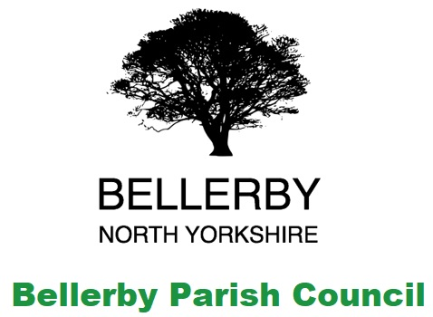
Bellerby Parish Council
Clerk: Lynn Watkinson 5 Belle Vue Terrace, Bellerby, DL8 5QL / email bellerby.pc@gmail.com
I hereby give you notice that the Parish Council meeting will be held on
Monday 16th March 2020 in Bellerby Memorial Hall at 7:30pm
All members of the Council are hereby summoned to attend for the purpose of considering and resolving upon the business about to be transacted at the meeting as set out hereunder.

Agenda for the meeting:
Procedural Matters
- To Note Apologies and Reasons for Absence.
- “To receive disclosures of personal and prejudicial interests from Councillors on matters to be considered at the meeting.
The disclosure must include the nature of the interest. If you become aware, during the course of a meeting, of an interest that has not been disclosed under this item you must immediately disclose it. You may remain in the meeting and take part fully in discussion and voting unless the interest is prejudicial.
A personal interest is prejudicial if a member of the public with knowledge of the relevant facts would reasonably regard it as so significant that it is likely to prejudice your judgement of the public interest and it relates to a financial or regulatory matter.”
- To approve the minutes of the last meeting
- Public questions, comments or representations (limited to 10 minutes)
Business Matters
- To receive information on the following ongoing issues and decide actions where necessary:
Review Clerks Report
Summary of Action Points:
Action point | Lead | Status
Monitor Footpath Project | Cllr Rycroft | NYCC response received- See Clerks Report
Renovate Telephone Kiosk | Cllr Chilton | Base to arrange
Strategic Plan | Council | Ongoing
Electrical Connection | Clerk | Connection completed.  Meter installed.  Fuse board and connections to arrange.
Allotment/Community Garden | Clerk/Chairman | Installation of gates arranged.  Artwork commissioned.  Further funding applied for.
Meetings, Notices and Consultations.
- To consider the offer of a donation to install a memorial bench on the concrete plinth at the Sycamore tree.
- To receive an update on the Community Garden funding applications and consider attendance at the Bellerby Open Gardens AGM.
- To receive an update on the arrangements for the Annual Parish Meeting.
- To discuss the work required to the burial ground.
- To consider arranging a tree survey for the village.
- To discuss the issue of cars parking and driving over the village greens and verges as well as the increase in speeding through the village.
- To consider the Flood Action Plan and distribution of funding from the Two Ridings Foundation prior to it being discussed at the Emergency Committee meeting of 23rd March 2020.
- To discuss the potential of facilitating a joint village insurance policy.
- To consider planning matters:
New Planning Applications:
- To consider correspondence received since the last meeting and approve actions required
- Authority to pay
Opening Balance at 01/03/2020: £25,805.05
Of which is ring fenced: £19,289.40
Working Balance: £ 6,515.65
Payments
Cllr Travell | £119.16 | 248 | 100120 | Dammit Putty
Clerk | £17.01 | 249 | 100121 | Stationery
Norris & Fisher | £235.47 | 250 | 100122 | Insurance Year 3
Clerk | £8.40 | 251 | 100123 | Postage
Receipts
Two Ridings Community Foundation | £10,00.00 | R55 |  | Flood repairs & equipment
Other payments: Clerks salary & website hosting.
- Exchange of views and ideas
- Dates of next meeting:
27th April 2020 Annual Parish Meeting
11th May 2020 Annual Meeting

