Minutes of the Annual Meeting of Thornton–le–Moor with Thornton–le–Street Parish Council held at 7.00pm on Tuesday 6th May 2025 at Thief Hall, Thornton–le–Moor, Northallerton, North Yorkshire
Parish Council Annual Meeting

Present: Councillors: J. Barker (Chairman) B. Stockdale, R. Barr and P. Hodgson.
Clerk: D. Robson-Booth
Attended by seven members of the public
- Election of Chairman
The Parish Council nominated Jessica Barker and she accepted the role for a third year. She signed the ‘Declaration of Acceptance of Office’ at the end of the meeting.
- Election of Vice Chairman
Bill Stockdale accepted the role of Vice Chairman.

- Apologies for Absence
J. Pinches and Cllr Alyson Baker (NYC Councillor)
The chair approved the apologies.
- Parish Council Chairman’s Report

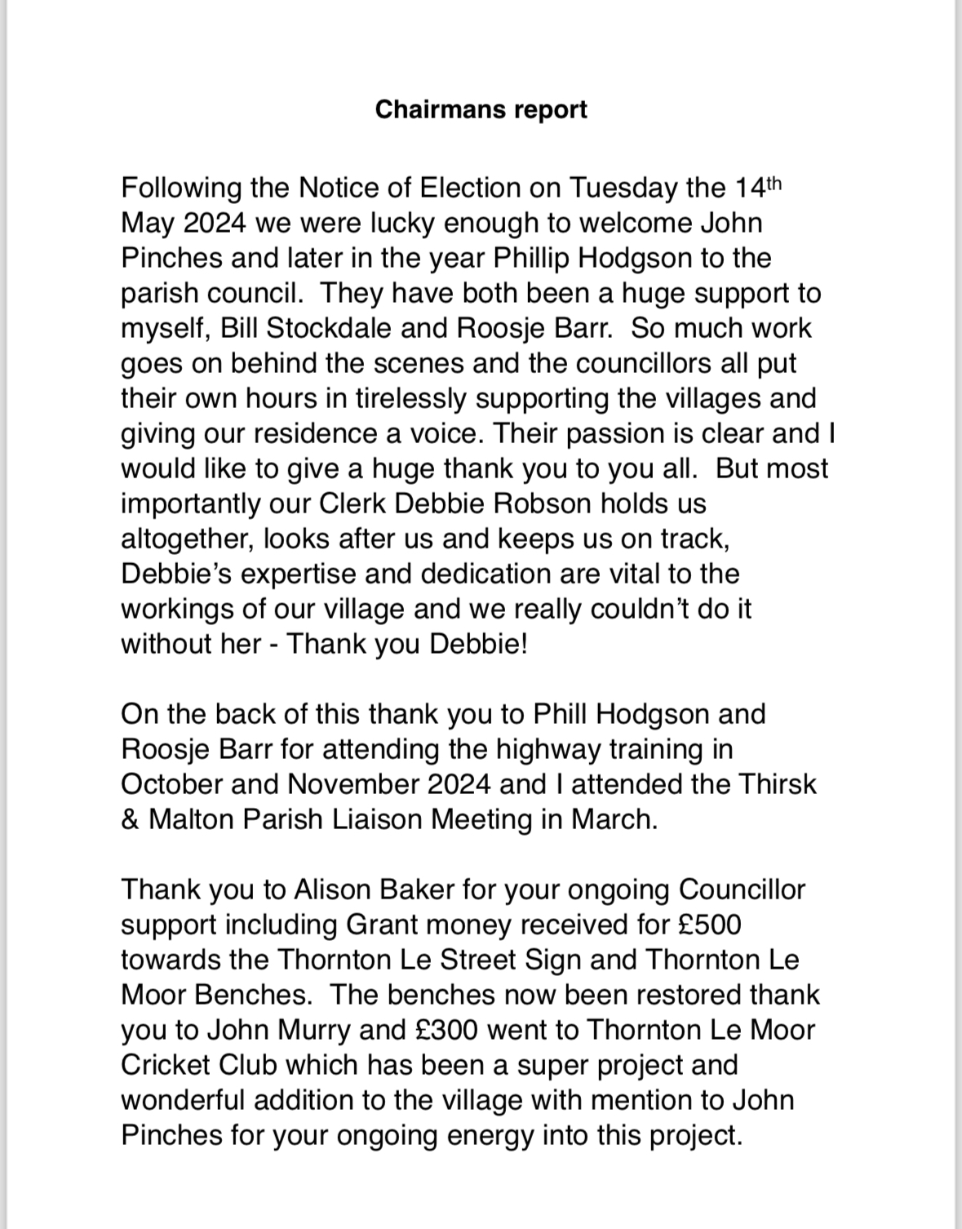
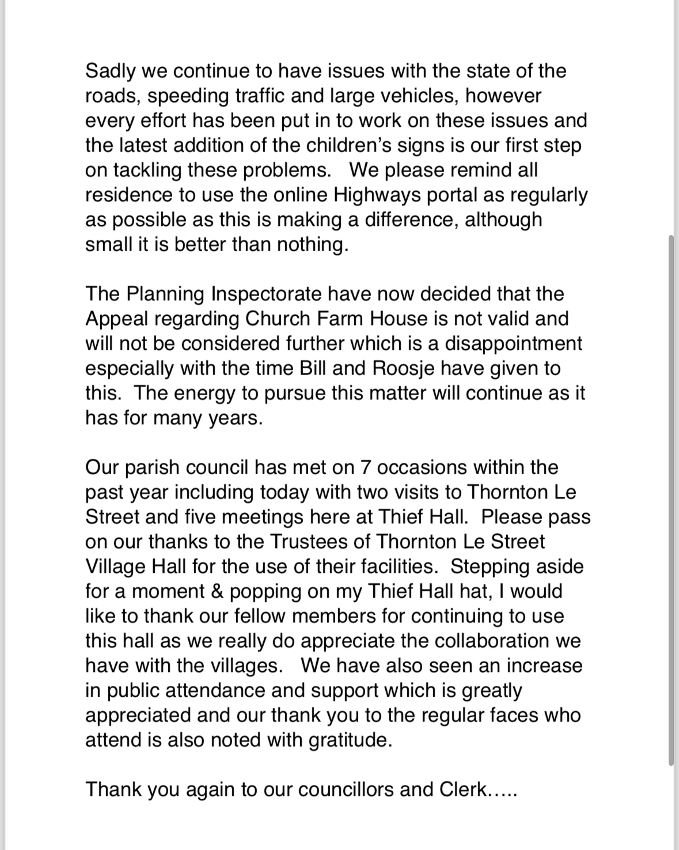

- Church reports for Thornton le Street and Thornton-le-Moor.
St. Leonard’s Church Thornton le Street
The weekly Services continued to be well attended throughout the year, with numbers ranging from 8 to 15. Two new members have transferred into this congregation.
Special Services have been particularly well attended with congregations up to 35.
The service to celebrate the harvest was followed by a cooked supper and afternoon tea was served after the Carol Service at Christmas. During the fine weather in July a “Summer Praise” was held in the open air which attracted many and included a strawberry tea.
Following a R.C. funeral service in Thirsk, a burial took place in St. Leonards churchyard.
The Friendship Lunches with a cake and gift stall, continue to be held monthly in the Village Hall bringing the community together and raising funds for the upkeep of the church.
All food and gifts are donated and we are very grateful to the friends who give their time and help in any way and those who continue to support us.
During the year the Deputy Wardens have continued to carry out general repairs and maintenance of the building and the churchyard. Drains and gutters were cleared in Spring and November, the grass has been regularly cut and strimmed around the gravestones and paths kept clear of debris and snow. Immediate repairs were carried out to replace a broken tile on the roof, a damaged piece of floor-boarding and a broken drain cover. Fire Extinguishers were serviced and visual checks have been carried out on electrical equipment, trees and gravestones.
The Deputy Wardens wish to thank all the members of the congregation and all those who support us in any way to keep our church running effectively.
Thornton Le Moor
Two outdoor services were held at Thornton le Moor during the year, the first in June for St. Barnabas Day (the name of the original church on this ground), and the second in November for Remembrance Day. Many thanks to all who help to make these events possible and provide welcome refreshments.
- Thornton-le-Street Village Hall Report

Thornton-le-street and North Kilvington Village Hall
Chairman’s Report Year Ended Sept 2024.

The Village Hall has been quite busy this year. I would like to thank all our regular users for their continued support and all those who have made use of our various facilities for their private events.
I am pleased to welcome a new regular class of Pilates and look forward to a possible Line Dancing Class in the near future.
We were sorry to lose the Upholstery Group for a few weeks as the class organiser was recovering from an injury. We wish her a full and speedy recovery and hope to see her back very shortly.
All the events have run smoothly and been very successful. The Christmas party for the Uganda Education Project made full use of the kitchen to provide a hot meal for nearly 40 people and included a live video link to the children in Uganda which was very moving
The video facility was repeated for the Chinese Reunion, a private event, when a link was arranged with friends in Canada.
The Hall has been very useful for charity events. Those benefitting this year include: The Yorkshire Air Ambulance, the Salvation Army, Christmas appeal for the Homeless, Toys for Children at Christmas, The Ugandan Education Project, McMillan Cancer Care and Hambleton Foodshare.
A Mexican Trains Evening raised funds for the Village Hall.
Many thanks to the PG group for hosting several social events during the year including a Pub Night, Fish and Chips, Pizza Evening and an outdoor summer picnic. An essential part of being together as a village.
The hall has also been used by the PCC of St. Leonard’s Church for their regular meetings and special events when good use has been made of the IT equipment. The monthly Friendship Lunch continues to be the main fund raiser for St. Leonard’s Church.
The local Parish Council also uses the hall for alternate meetings.
It has also proved a popular venue for children’s and family parties.
Lindsey and Christine have also made full use of the hall for their dog training sessions. Thank you for their continued support.
Many thanks to all our users for keeping the hall in good condition and being respectful of other users. Thanks also to our regular cleaner who maintains the hall between uses.

There have been no major maintenance projects this year although lots of minor work has been carried out. This is described in more detail in the Treasurers Report which follows.
One major future project is to install solar panel to off-set the electricity bill. This is not without its problems due to our energy supplier, but we are hopeful that a solution will be found.
I have already thanked our patrons for their continued support, may I also thank Barbara for cleaning the hall and maintaining housekeeping supplies, all those who continue to help on the flower rota especially Jo and Paul who have kept the flower display looking good over the summer.
Thanks also go to all those who have attended events at the Village Hall and continue to support us in any way.
And a special thank you to Lindsey and Rob for taking the bookings and keeping the calendar up to date.

Barty Lee
Chairman

May I draw attention to some future events?
The Village Christmas Carols and Christmas Draw will be on Wednesday 18th December. This includes mince pies and mulled wine.
The Salvation Army Christmas Fayre is on Saturday 16th November. Any offers of help or donations of toys or tombola prizes, please pass these on to Rene.


- Thornton-le-Street History Group - Report for Annual Parish Meeting
Report of year’s activities – April 2024 to March 2025

Overview – we run activities relating to history and heritage for the enjoyment of those involved, encouraging collaboration with other groups, and disseminating findings to the wider community.
Steering Group – the history group is led by a Steering Group of 6 people who have met 4 times this year to plan and review activities. This included meetings with the National Trust about working with them at Beningbrough Hall and Nunnington Hall.
Funding – We are a self-funding group with events run at cost, and donations are welcomed, for example to pay for webinar speaker costs.
Supporters - Our email contact list has continued to increase this year - we now have over 400 supporters.
Publications - Our first book - Thornton-le-Street – The Archaeology and History in its Landscape has continued to be popular with further copies being sold after webinars attracted new supporters to our group.
Key dates and activities
4 Webinars were shown this year – 2 were recorded for showing on our YouTube channel to give access to a wider audience. 315 people watched these webinars.

- Yannick Signer on Pottery Production in Yorkshire: Old Questions, new data
- John Buglass on The Archaeology of Burials or Dead Men’s Tails
- Dr James Wright on Historic Building Myth Busting in Yorkshire
- Dr Lauren McIntyre on Highway to Hull, the excavation of Hull Trinity Burial ground
Activities
- Walking Tour at Beningbrough Hall led by the National Trust’s Head Gardener
- Fieldwork - Archaeological dig at Nunnington Hall for the National Trust ahead of their new Iris Garden being constructed. Our work included talking to the public as part of the CBA’s National Festival of Archaeology.
- Processing of finds from Low Swainby & Beningbrough Hall – led by PhD student Yannick Signer and Mark Newman, Archaeologist from The National Trust.
- We are also working with Yannick Signer, extending our research on our medieval pottery finds from Low Swainby and Thornton-le-Street. This will be reported through Yannick’s PhD dissertation.

Publicity/Comms
- Village hall displays - the RTTP Timeline and Finds Display Cabinet continue to be of interest to village hall visitors and those attending RTTP events.
- X formerly Twitter – 203 followers
- Website – includes a wide range of resources.
- Eventbrite advertises our events, gathers delegates’ feedback and collects donations for us.
- YouTube – our channel hosts our 3 videos and our 17 recorded webinars.
- Our most watched webinar has had 1.4k views! Traditional Farm Buildings of the Yorkshire Dales
- Zoom Webinar platform is used to host our webinar presentations.
- Contact Lists – over 400 email addresses on our supporter contact list. Additionally, 18 professional partners and 18 village/general email contacts. Webinars led to additional contacts.
- CBA Yorkshire advertises our events.
- Durham Univ. Archaeology Dept – we have a reciprocal arrangement to circulate each other’s events.
We continue to welcome both local people and those from further afield to participate and enjoy the events that we are providing.
Acknowledgments - We are grateful to North Yorkshire Council for their financial support, to all those who have generously made donations to help fund our activities and to all our supporters from near and far.
Beningbrough Hall Tour - June 2024 – Group photo and Mediterranean Garden, the final stages
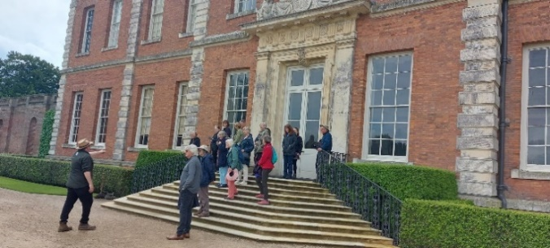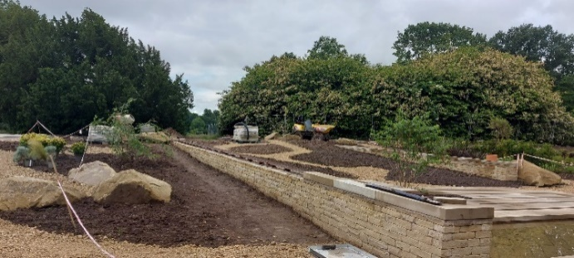

Archaeological dig at Nunnington Hall – Fri 26 July, Sat 27 July, Sun 28 July 2024
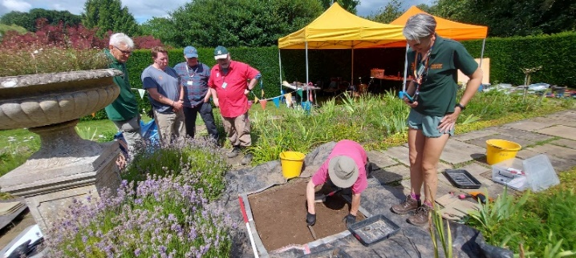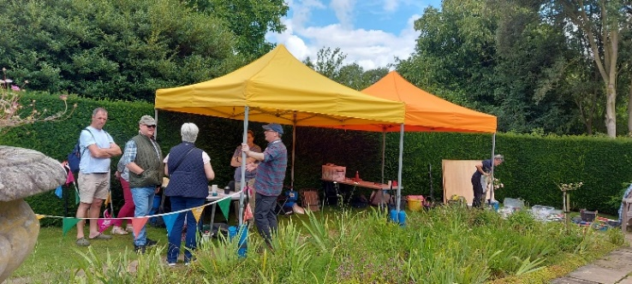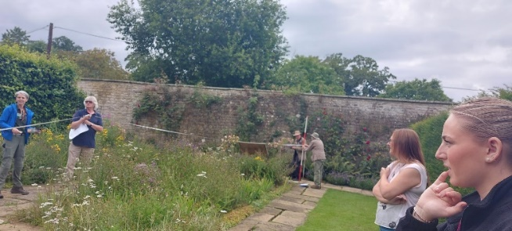

- Thornton-le-Moor Village Society Report - Not received

- Thornton-le-Street PG Group
Report for the Annual Parish Meeting Tues 6 May 2025
Thornton-le-Street PG Group organises village get-togethers for neighbours, family & friends.
Events during 2024/2025 included -
A village picnic in Ford Cottage paddock with garden games
Pizza and Quiz night
A Fish and chip supper
Coffee morning with donations to McMillan Nurses
New Year’s Day Walk
Line Dancing
Two Pub nights with darts, table football, table tennis, dominoes & cards.
Planned events
Great Get Together
Bingo
Village social night
Fish & Chip Supper & Quiz
New Years Day Walk

- South Otterington School Report

SOUTH OTTERINGTON C of E Primary School (Dales Academy Trust)

‘Shine Like Stars in the Universe’
Philippians 2:15
Our vision provides a guiding light to the pupils, staff, Governors and parents to ensure we have a dynamic mix of high achievement for all, exceptional pastoral care and expansive opportunities for the children. We want our children to become the exemplary citizens of the future. We are a vibrant, happy, family orientated community where everyone really feels they can flourish and achieve anything to which they set their minds
and hearts.

This year (2024-2025) we have 95 children on roll and 18 children enrolled in Pre-School. The attendance has improved during this academic year and we currently stand at 97.4%, which means we are above the Government national benchmark of 95%.

Number on roll and class organisation
We have four classes in School- Venus (EYFS), Earth (Y1/2), Neptune (Y3/4) and Mars (Y5/6). The names of the classes were chosen to fit in with the vision of our school and you will notice lots of stars and planets in the school environment. We have two new teachers who have joined us during the last year. Miss Naomi Lanham is our Lead for the Curriculum and Mrs Henderson has joined us in EYFS to job share with Mrs Richford. We are delighted they have joined us.

Class | Children | Teacher(s)
Venus | 14 Reception/ Y1 and 18  Preschool children | Mrs Richford, Mrs Henderson, Mrs Eynon (TA) and Mrs Metcalfe (TA)
Earth | 18 x Y1 and Y2 children | Mrs Fraser, Mrs Stamp (TA) and Mrs Rowland (1:1 TA)
Neptune | 32 x Y3 and Y4 children | Miss Lanham, and Ms Cooke (TA)
Mars | 31 x Y5 and Y6 children | Mr Brown , Mrs Peacock (HLTA) and Ms Davies (1:1 TA)

We were delighted and proud to receive our OfSTED report on 12/13th November 2024, which gave us the following grading’s of:

The quality of education: GOOD

Behaviour and attitudes: GOOD

Personal development: GOOD

Leadership and management: GOOD

Early year’s provision: GOOD

The start of the Report very much sums up the vision and values in our school:

What is it like to attend this school?
South Otterington Church of England Primary School is welcoming and caring. Pupils feel safe and valued and enjoy their time at school. Staff set high expectations for pupils’ achievement and behaviour. The school’s vision, to ‘shine like stars in the universe’, inspires and motivates pupils. They take pride in their work and conduct.
There is high ambition for all pupils, including those with special educational needs and/or disabilities (SEND). The school has introduced a well-considered curriculum. Pupils are excited by lessons and discuss their learning enthusiastically. They achieve well in most subjects. Pupils behave well. They show kindness and respect toward each other and their teachers. The school’s ethos is important to both pupils and parents. Pupils value the rewards and recognition they receive in collective worship time. Pupils also enjoy choosing staff members to receive a ‘shiny’ award each week.
Pupils learn how to keep themselves safe online and in the local area. Pupils are confident that staff will listen to them if they are worried. Relationships across the school are nurturing. Pupils are proud of the family-like atmosphere, where everyone feels they belong.

I was so very proud to be the Head teacher of our school when I read this, as it very much sums up the vision I have always had for our school.
Our school routines have continued and we have a number of After School Clubs running including Netball, French, Football and our Sports Leaders (Y6 pupils) run a lunchtime club for the EYFS children.
We had a Wheelchair Basketball club in the Summer term and this is booked again to visit during our Sports Week in June.
The pupils have been on a variety of school visits during the year including PGL at Newby Wiske, Ripon Workhouse and the Synagogue in Darlington.
Our Y6 children completed their ‘mini-medics’ First Aid training in October. We continue to sign the Lord’s Prayer in our Collective Worship each day, led by our Collective Worship Star hosts. Our Christian Values for this academic year are the Seven Stars of South Otterington: Integrity, Respect, Perseverance, Wisdom, Creativity, Kindness and Thankfulness.
We are delighted that Canon Stephen will be holding Confirmation classes in school during April and May ready for the Confirmation service on Wednesday June 25th at 7pm with Bishop Barry. The Bishop is also coming to meet us and visit school on Wednesday 18th June.
The Writing Shed and the Reading Shed continue to be a huge success for the children during playtime and lunchtime. We are raising money this year to continue our Woodland school sessions with Dr Kat and to replace our 10 scooters for playtimes- they have had too much use!!

Governance
Our Governing body continues to be a valuable and active support to our school. We have a new Chair of Governors- Mr John Kelly and two new parent Governors have joined us this year.

Links with St. Andrews
We have been able to use St Andrew’s for our celebrations during this year- we had our Harvest, Christmas and Ash Wednesday services in church and were able to invite our parents- many thanks to the Red Pinny Brigade who are always happy to support these events. Ash Wednesday was a new service to add to our calendar and was very special. We also hope to also have a Pentecost service this year in St Andrew’s.

We donated tins to the Hambleton Food Share from our Harvest collection and we supported the Poppy Appeal. We sang Christmas Carols around the Christmas tree outside school and performed our Key Stage one Christmas performances in the school hall.
We have paid for Tony to go to school in Uganda and our pupils decided after meeting him and Jocelyn in a live TEAMs call last year that they also wanted to pay for Jocelyn to go to school. Rev. Sheilagh went to visit the family in May 2024, but unfortunately Tony and Jocelyn were away visiting family in a different region when she was there.

Collaboration
We have continued to work very closely with the other Dales Academy Trust schools-
All Saints Secondary School, Croft, Trinity Schools (Richmond), Ainderby Steeple, Kirkby Fleetham, Barton, Ravensworth, East Cowton, St Francis of Assissi, Thornaby, Great Smeeton and Carnagill Community school.

We warmly invite you to join us for Collective Worship, which is at 2.55pm each day, so you can see our Christian vision and values at work.
I look forward to meeting you all,
Kind regards,
Amanda Gledhill
Headteacher
South Otterington CE Primary School is strongly committed to using the Ethical Leadership Framework to create and uphold an ethos that stresses high achievement, equal opportunities, the valuing of cultural diversity, the provision of a secure.

The next ANNUAL MEETING will be held in MAY 2026 TBC
Signed by Chairman:
Date:

