GATE & UPPER HELMSLEY PARISH COUNCIL
MINUTES OF A PARISH COUNCIL MEETING HELD IN THE VILLAGE HALL
ON THURSDAY 08 DECEMBER 2022 AT 7.30PM
Councillors Present: Janet Buckley Charlie Dodds Jonathan Greenwood Michael Harrison Richard Miller Sue Panesar
In Attendance: Fiona Hill - Parish Clerk
Public Present: 9
23/28 a) To receive apologies for absence given in advance of the meeting: NYCC/RDC Cllr Caroline Goodrick
b) To consider the approval of reasons given for absence: N/A

23/29 To record declarations of interest in items on the agenda: None

23/30 To confirm the minutes of the meeting held on Thursday 08 September 2022:
Resolved/Approved (Unanimous)

23/31 To discuss matters arising from previous minutes: Back Lane – Andrew Santon, Highways Customer Communications Officer, NYCC had emailed (14Oct22) as follows – “Further to my email of 28th March, I can confirm that the decision has been taken not to progress to a full public consultation about making a short section of The Lane one way. After hand delivering 60 letters asking people to comment on the proposal we only received 20 responses. Fourteen people supported the proposal and six residents were against it. An additional resident supported the proposal at a later date. Unfortunately there is not sufficient support to divert our limited resources to fund a full public consultation. I am sorry that this isn’t the answer some parish councillors would like to receive but I hope they can appreciate the need for us to prioritise public resources carefully”. Resolved - The Parish Council reluctantly accepted this outcome, but would ask if any other traffic calming measures could be installed along Back Lane and the Upper Helmsley Road junction. (Unanimous)

Road Safety issues adjacent to BATA – Andrew Santon, Highways Customer Communications Officer, NYCC had emailed (06Oct22) as follows – “Thank you for your email. It is a shame the tractor driver decided to ignore the ‘Keep Clear’ markings whilst stopping to visit the services. Was the tractor parked there for a long time? In this situation drivers exiting the garage forecourt have to drive to the conditions and stop in a position where their zone of vision to the right is less obscured. This could be well behind the normal stopping position. Then when there is a break in the traffic from York pull forward to the normal position and position at an angle to allow you to ‘peep and creep’ forward to confirm the road is clear. It does make it more difficult but an experienced driver who is driving defensively should be able to cope. Please see the diagram below:

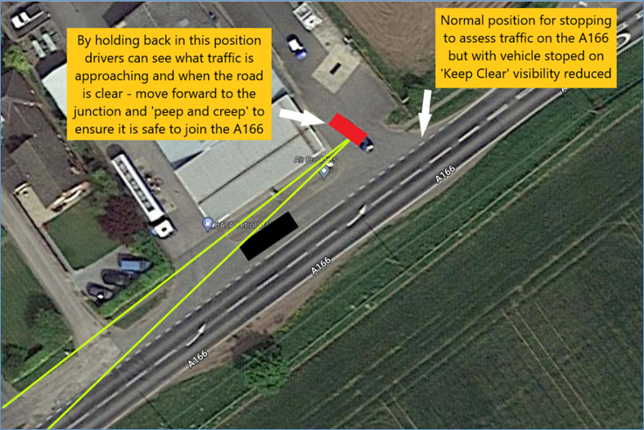

There is not a great deal more we can do in this location. If vehicles are parked on the ‘Keep Clear’ the police may be able to ‘advise’ drivers not to park there but local policing priorities will dictate whether any resources can be allocated to this matter. I’m sorry that this will not be the answer the Parish Council was hoping to receive”. Resolved - The Parish Council reluctantly accepted this outcome, but would ask City of York Council, who owned at that side of the A166, to make good the worn area opposite then garage. In addition, the Parish Council would ask if NYCC Highways if the A166 could be covered with quiet tarmac. (Unanimous)
Website – The development is now finished and the Parish Council had seen PDF screenshots of all the pages. The Domain Name would be gateandupperhelmsley.org.uk The cost are £250 one time fee and £25 per hour. There are ongoing cost for domain name ownership, hosting, etc. Resolved – The Parish Council agreed to proceed with this website as quoted. (Unanimous)
Defibrillator – The defibrillator was no longer working. Yorkshire Ambulance Service had contacted the manufacturer, who had quoted £121.63 plus VAT to investigate the device, but could not guarantee repair. Resolved – The Parish Council would used the money pledged via the RDC Rural Community Grant Scheme to purchase a new defibrillator. Cllr Harrison would liaise with the electrician and the owners of Prospect House about the siting of the unit. Cllr Greenwood would deal with the governance of the defib once in situ. (Unanimous)

23/32 Public Session: There was a discussion about some bollards, which were fitted then removed, from land at the side of the highway. Cllr Goodrick had advised the Parish Council that this was an issue between NYCC Highways and the householder, so the Parish Council would not become involved.

The Parish Council were asked if a bus shelter could be installed opposite the public house.
Resolved – The Parish Council agreed to ask City of York Council (Unanimous)
23/33 To discuss new planning applications received: 22/01068/HOUSE – Erection of single-storey extension to rear following demolition of existing external store/utility room @ Gate Helmsley House, York to Driffield Road Resolved / No Objections (Unanimous)
23/34 To discuss matters raised by Parish Clerk/Responsible Financial Officer:
Bookkeeping records to date – The bank reconciliation totalling £3766.59, along with the Income and Expenditure had been circulated around Cllrs
Financial Management - The bank mandate would be completed to add as signatories Cllrs Greenwood, Miller and Panesar. Cllrs Buckley and Harrison would remain as signatories
Budget/Precept 2023/2024
Resolved / The Parish Council agreed a precept of £5000.00 against an possible expenditure budget of £7675.00
Policy Review The Parish Clerk had completed a review of the basic governance section of the policy list. Statutory Required (SR) Policies: Standing Orders Resolved / Adopted (Unanimous) Financial Regulations – Version adopted is still up to date, so no action required. Code of Conduct – Version adopted is still up to date, so no action required. Committee Terms of Reference – Not required, as the Parish Council does not have any committees Best Practice (BP) Policies: Co-option Policy and procedure – YLCA have updated the guidance. If a person wishes to become a Parish Councillors and there is a vacancy, then they should be allowed to become a member. The only time the Parish Council has a choice is when there are more interested parties than vacancies. A template Co-option Policy, along with a template Eligibility Checker had been circulated around Cllrs. The Parish Clerk advised that the Parish Council does not require these - Member’s Interests Log, Dispensation Request form, Member’s Dispensations Log, Example of a Scheme for Members Allowances, Councillor attendance register, Planning register. Next, the Parish Clerk will review the section for Openness and Accountability.
Matters raised by/with Yorkshire Local Councils – NTR
Payment approval - None

23/35 To report correspondence received by the council: RDC Rural Community Grant - Ryan Gaughan, Community Engagement Project Officer, had emailed (28Nov22) – “Thank you for your applications and the supporting information. We sat down as a team and reviewed all applications received so far. Unfortunately, the scheme was undersubscribed, so we have decided to hold a second round for applications – this will close on 13th December 2022. Groups that have already applied are eligible to apply once again, however this must be for a different project. First time applicants will be prioritised. Decisions on all applications will therefore be made following the new closing date, however I can assure you that you will receive at least £1467 for each of the applications you have already submitted”. Resolved - The Parish Council would await to hear further. (Unanimous)
NYCC Energy increase - Gate & Upper Helmsley lighting - Jennifer Aspden, Energy and Asset Management Officer, had emailed (19Oct22) – “You will no doubt be aware of the escalating costs during the current energy crisis. North Yorkshire County Council is exempt from these increases which have had a significant impact on our annual street lighting energy bill. As with domestic properties, costs are spiralling and where in 2021/22 we were being charged 16.93p/kwh, our rate has risen to 36.91p/kwh. Unfortunately, as an existing customer on our current street lighting energy account your Council will also be subject to this increase in cost. I am informed that there may be further increases in April 2023 but as yet, I am unable to give you any assurance as to what the new figure might be. As a result, I would encourage you to test the energy market before agreeing to continue with the County Council. Your energy invoice for 2022/23 will be £1517.38 + admin + VAT. It may be time for your Council to consider the wholesale replacement of your footway lighting stock with new LED technology. For an investment of around £339 per lantern (12 lanterns) there is a resulting energy saving (at 36.91p/kwh) of £1109.38/year so the pay back on your investment would be 3.5 years. The above costs are subject to our ability to install the new LED lanterns on the existing infrastructure, brackets, posts and columns etc. Where we have undertaken this exercise in the past we have had to replace some bracket arms, electricity supplies and the odd column due to age or condition which all add to the cost. Should your Council consider moving forward with the conversion of your equipment to LED my colleague Nick Wilson can supply you with any necessary information to enable you to work out accurate costs and payback. This will most likely involve a visual structural inspection that is normally costed out at around £10/column. Nick can be contacted at Nicholas.Wilson@northyorks.gov.uk At the same time, your Council could also consider implementing part-night lighting as the County Council has on its own roadway lighting. There will be an energy saving, albeit at the cheaper overnight rate, however there would be no additional cost associated with the installation of the necessary equipment if it’s completed at the same time as the LED installation. If you require any further information regarding this, or any other lighting matter, please do not hesitate in contacting myself or Nick”. Resolved - The Parish Council would ask NYCC to clarify if all lanterns were owned by the Parish Council, if another supplier could be approached to quote for electricity, if the Parish Council could purchase and fit their own LEDs (Unanimous)
23/36 To receive matters raised by members: None

23/37 To confirm the dates of the future meeting(s):
02 March 2023, 04 May 2023, 07 September 2023, 07 December 2023
Resolved / Approved (Unanimous)

