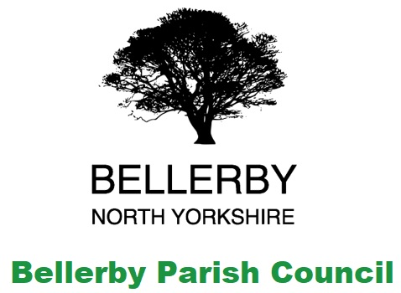
Annual Parish meeting for Bellerby
was held on
Monday 25th April 2022 at 7:30pm
in Bellerby Memorial Hall DL8 5QN

The meeting was attended by:
The clerk Lynn Watkinson.
Parish Councillors Hutchinson, Chilton, Scriven & Singleton
District & County Councillor Sedgwick
Representatives from the village organisations
Members of the public were also present

Business Matters

- To receive the annual report of the Parish Council from the Chairman
The Chairman read out his report.
Cllr Sedgwick reported that a Unitary authority webinar would be presented on 26th April 2022 at 6:30pm.
- To receive a verbal annual report from the Bellerby Memorial Hall Chairman
The Chairman read out the report and answered questions. A written report would also be submitted
- To receive a verbal report from the Walker Trust
The Chairman read out the report and answered questions. A written report would also be submitted
- To receive a written report from the Bellerby Study Group Chairman
The Chairman of the Parish Council read out the written report.
- To receive a written report from the Bellerby Freeholders
The Freeholders circulated a copy of the account figures
- To receive a written annual report on the Bellerby Community Garden
Cllr Singleton read out the Annual Report from the Steering Committee
- To discuss any items raised by the residents of Bellerby
An approach to include an audio record of the meetings and supporting documents on the website had been received. This would be included on the Parish Council agenda
Cllr Sedgwick asked if a site meeting for the Footpath project had been held. It was noted that a meeting had been arranged in 2019 but was cancelled as a result of the pandemic and no further dates had been received
- Closing comments from the Chairman
The Chairman noted that a vacancy existed on the Parish Council should anyone be interested in the role.
He also thanked everyone for attending and for the reports received which would be circulated in a newsletter shortly.
Meeting closed 19:58

