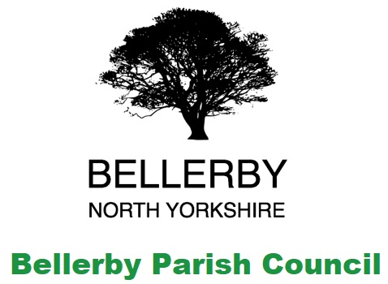**Bellerby Parish Council**

Clerk: Lynn Watkinson 5 Belle Vue Terrace, Bellerby, DL8 5QN / email bellerby.pc@gmail.com

I hereby give you notice that the Parish Council meeting will be held on

Monday 10th January 2022 at 7:30pm

In Bellerby Memorial Hall DL8 5QN

All members of the Council are hereby summoned to attend for the purpose of considering and resolving upon the business about to be transacted at the meeting as set out hereunder.

Agenda for the meeting:

Procedural Matters

1. To Note Apologies and Reasons for Absence.
2. “To receive disclosures of personal and prejudicial interests from Councillors on matters to be considered at the meeting.

*The disclosure must include the nature of the interest. If you become aware, during the course of a meeting, of an interest that has not been disclosed under this item you must immediately disclose it. You may remain in the meeting and take part fully in discussion and voting unless the interest is prejudicial.*

*A personal interest is prejudicial if a member of the public with knowledge of the relevant facts would reasonably regard it as so significant that it is likely to prejudice your judgement of the public interest and it relates to a financial or regulatory matter.”*

1. To approve the minutes of the last meeting
2. Public questions, comments or representations (limited to 10 minutes)

Business Matters

1. To receive information on the following ongoing issues and decide actions where necessary:

Clerks Report

Summary of Action Points:

|  |  |  |
| --- | --- | --- |
| Action point | Lead | Status |
| Monitor Footpath Project | Clerk & Cllr Hutchinson | Awaiting a site meeting with Highways and their contractor to determine design  Cllr Sedgwick will provide updates for the project going forward  An update has been received from Cllr Mackenzie as reported in the Clerks report |
| Strategic Plan | Council | Ongoing |
| Community Garden and Allotment | Clerk | A Public Meeting has been arranged to form a working committee – **see agenda item 7**  Additional funding streams being sought |
| Flood Management Feasibility Study and alleviation works | Clerk | Meeting to be arranged with the solicitor for the transfer of Quarry Heads. |
| Burial Ground | Clerk | Funding application submitted.  Camera investigative work completed and no issues found. |
| Gritting | Clerk | NYCC Highways have sent through a number of questions – **see agenda item 9** |

Meetings, Notices and Consultations.

1. To receive an update on the speed concern campaign
2. To receive an update following the meeting to form a Community Garden committee and decide actions were necessary
3. To consider the offer from Bellerby Open Gardens for financial support for a tree survey
4. To consider the questions received from Highways with regard to the gritting of Moor Road and Church Street along with the response from Metcalfe Farms
5. To consider the Urban Grass cutting payment offer from North Yorkshire County Council of £44.78 for 2022
6. To discuss the correspondence from the Leyburn Community Support Organisation
7. To review and approve the revised updated Asset and Liabilities Register
8. To consider planning matters:

Planning Responses:

New Planning Applications:

*None*

1. To consider correspondence received since the last meeting and approve actions required
2. Authority to pay

Opening Balance at 01/12/2021: £53,750.06

Of which is ring fenced: £54,338.65

Working Balance: -£849.75

|  |  |  |  |  |
| --- | --- | --- | --- | --- |
| **Payments** |  |  |  |  |
| Clerk | £11.79 | 346 | 100213 | Stationery |

Other payments: Clerk’s salary, electrical supply & website hosting.

1. Exchange of views and ideas
2. Date of next meetings: 14th March 2022

|  |  |
| --- | --- |
| 25th April 2022 Annual Parish Meeting | 9th May 2022 Annual Parish Council Meeting |