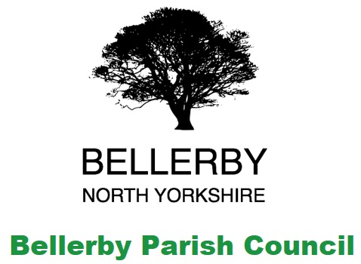

**Annual Meeting of Bellerby Parish Council**

Clerk: Lynn Watkinson 5 Belle Vue Terrace, Bellerby, DL8 5QN / email [bellerby.pc@gmail.com](mailto:bellerby.pc@gmail.com)

I hereby give you notice that the Parish Council meeting will be held on

Tuesday 14th May 2024 at 7:30pm

In Bellerby Memorial Hall DL8 5QN

All members of the Council are hereby summoned to attend for the purpose of considering and resolving upon the business about to be transacted at the meeting as set out hereunder.

**Agenda for the meeting:**

Procedural Matters

1. To elect a chairperson and sign a Declaration of Acceptance of Office of Chairman in line with the Local Government Act 1972
2. To approve apologies for absence
3. To elect a Vice Chairperson and sign a Declaration of Acceptance of Office of Vice Chairman
4. To resolve to permit any councillor that is unable to sign their Declaration of Acceptance of Office at this meeting, or who has not undertaken this task before this meeting, to sign their Declaration before or at the next ordinary meeting of the Council
5. “To receive disclosures of personal and prejudicial interests from Councillors on matters to be considered at the meeting.

*The disclosure must include the nature of the interest. If you become aware, during the course of a meeting, of an interest that has not been disclosed under this item you must immediately disclose it. You may remain in the meeting and take part fully in discussion and voting unless the interest is prejudicial.*

*A personal interest is prejudicial if a member of the public with knowledge of the relevant facts would reasonably regard it as so significant that it is likely to prejudice your judgement of the public interest and it relates to a financial or regulatory matter.”*

1. To approve the minutes of the last meeting
2. Public questions, comments or representations (limited to 10 minutes)

Business Matters

1. To receive information on the following ongoing issues and decide actions where necessary:

Clerks Report

Summary of Action Points:

|  |  |  |
| --- | --- | --- |
| Action point | Lead | Status |
| Monitor Footpath Project | Clerk & Cllr Hutchinson | Awaiting a site meeting with Highways and their contractor WSP to determine design  Cllr Sedgwick will provide updates for the project going forward  Responses received from Rishi Sunak MP – copies attached |
| Community Garden and Allotment | Cllrs Singleton and Hutchinson | Site meetings have been held to progress the works  ***Item added to the agenda – item 17*** |
| Flood Management Feasibility Study and alleviation works | Clerk | Awaiting land transfer |
| Burial Ground | Clerk & Cllr Dilworth | Gates installed  Patio area work booked for 15th July |
| Gritting | Clerk | Area 1 Highway Customer Communication Officer is looking into the matter.  Metcalfe’s approached to grit as necessary |
| Speed Concern Campaign | Clerk & Cllr Singleton | 20s Plenty meetings attended  ***Item added to the agenda – item 16*** |

Meetings, Notices and Consultations.

1. To discuss the potential dates of meetings for 2024 – 2025
2. To sign the Chairman’s consent form from YLCA
3. To appoint up to two councillors to attend the YLCA Branch meetings
4. To consider and approve the financial accounts for the financial year 2022-2023
5. To approve the Annual Governance Statement 2022/23
6. To approve the Accounting Statements 2022/23
7. To approve the AGAR 2022/23 for submission to the External Auditors
8. To receive an update on the speed concern campaign and decide actions were necessary
9. To receive an update following the Community Garden meetings and decide actions were necessary
10. To consider the options for adopting a .gov.uk domain and decide on the level of service required from the list of approved Registrars
11. To consider the YLCA membership renewal at a cost of £147.00
12. To consider planning matters:

New Planning Applications:

*None*

Decisions Received:

*None*

1. To consider correspondence received since the last meeting and approve actions required
2. To consider approval to pay future invoices by electronic transfer where possible following approval at the parish council meeting
3. To consider approving payment of grass cutting invoices from Hybrid Property Care by electronic transfer as they are received
4. Authority to pay

Opening Balance at 01/04/2024: £3,657.70

Of which is ring fenced: £5,580.00

Working Balance: -£1,922.30

|  |  |  |  |  |
| --- | --- | --- | --- | --- |
| **Payments** |  |  |  |  |
| David Ward | £1008.00 | 501 |  | Burial Ground gates |
| North Yorkshire Council | £4620.00 | 502 |  | VAS sign |
| Hybrid Property Care | £360.00 | 503 |  | Grass cutting - May |
| Hybrid Property Care | £360.00 | 504 |  | Grass cutting - June |
| Sam Turner | £334.00 | 505 |  | Compost & troughs |
| YLCA Membership | £147.00 | 506 |  | Subscription |
| **Receipts** |  |  |  |  |
| Bellerby Open Gardens | £500.00 | R109 |  | VAS Donation |
| North Yorkshire Council | £6,3000 | R110 |  | Half Year Precept |

Other payments: Clerk’s salary, electrical supply & website hosting.

1. Exchange of views and ideas
2. Date of next meeting: to be confirmed