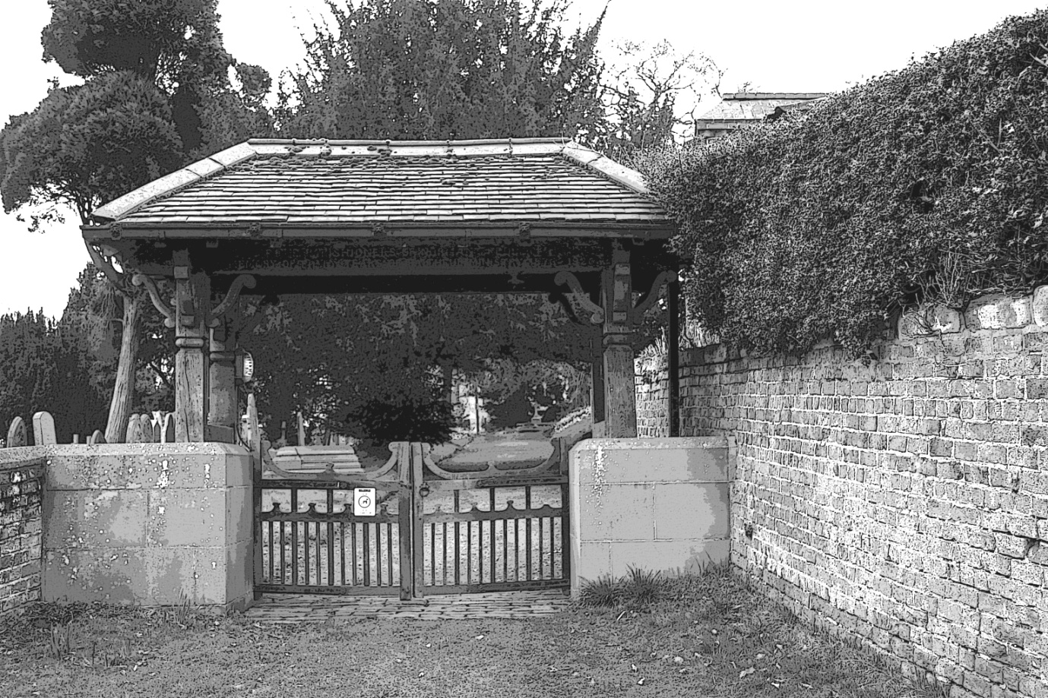

**Lych gate at St Peter's Church, Brafferton**

**Invitation to Attend Brafferton Parish Council Meetings**

Members of the public and press are invited to attend meetings of the Brafferton Parish Council meetings.

Meetings are usually held in the Dr Waud Room in Helperby Village Hall at 7.30pm. You are cordially invited to come along and hear discussion of local topics.

An agenda for each meeting will be displayed on this site and on the council notice board.

**Meeting Dates**

The Council meets on the third Wednesday of alternate months (Jan, Mar, May, Jul, Sep & Nov).

**Declaration of Councillors' Pecuniary Interests**

**Councillors:**

Chris Owens (Chairman)

Mavis Hartley (Vice-Chairman)

Janice Attwood

Cris Connor

Barry Connor

Councillors are required by the Localism Act (2011) to adopt a Local Code of Member Conduct and to register any Disposable Pecuniary Interests which may influence their actions as a Parish Councillor.

This Register is held by the Monitoring Officer at Hambleton District Council and may be viewed on the District Council website by navigating as follows:

* Visit the Hambleton District Council Homepage at http://www.hambleton.gov.uk/
* Scroll down to A to Z of council services/ **Select P**
* Select **Parish Councils**
* Scroll down to **Brafferton Parish Council**
* Select the individual councillor

**Council Documents**

The Local Government Transparency Code 2014 requires local councils to display certain accounts information on the internet. This information, plus agendas, minutes, Standing Orders and Policies can be accessed from the listed Resources here.

**A Little Local History of Brafferton**

The first settlers were probably Roman (70A.D. - 400A.D.) as the Roman road from Malton to Aldborough passed through the area of the village to cross the River Swale here at a ford. This will have given rise to the derivation Brafferton, 'Broad-ford-tun', or a town at the broad ford. Fords were always good places for an entrepreneur to set up trade. The 'ton' in the name indicates the Saxon origin of the village, thus making it older than its sister village Helperby.

St Paulinus, a follower of St Augustine, after converting in 625 Edwin, the Saxon King of Northumbria to Christianity and before becoming the first Bishop of York, chose the River Swale at Brafferton as a place of baptism. At Christmas, in the year 626, ten thousand people entered the river to be baptised and it is recorded that no casualty resulted, even though the numbers were so great. In fact, those who entered having some 'feebleness and infirmitie' or deformity, returned from the river 'whole and reformed'. Following the baptism, it is believed that Paulinus preached a sermon on St Augustine's instructions from the highest point in the village, which became known as St Augustine's Mount or Austin's Hill, as it is now known. Others believe that he preached the sermon where the church was built overlooking the river. As Paulinus carried out similar baptisms at other places on the river - notably Catterick - the Swale became known as the 'River Jordan of England'.

**Clerk**

Roger Clements

Wesley House

Bridge Street

Helperby

York

YO61 2NU

01423 360602

Email: brafferton.pc@ gmail.com