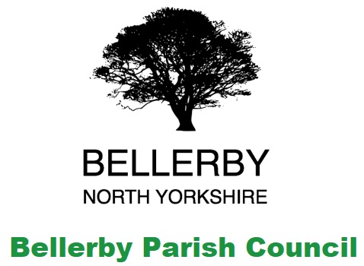**Bellerby Parish Council**

**Site meeting 21st September 2020**

**MOD Bellerby Ranges**

Attendees:

Chairman John Hutchinson

Clerk Lynn Watkinson

MOD DIO Representatives

NYCC Flood Risk Management Team

Washfold Farm Landowner

Bellerby Residents

A site meeting was held to consider potential flood alleviation work on MOD land at Bellerby Ranges in conjunction with the previously reported potential work on private and common land to the west of Bellerby to support the successful planning application for an access road and attenuation pond(s) at Washfold Farm.

NYCC Flood Risk Management team advised that the feasibility study was expected to be published in November 2020 for circulation to the Parish Council. The landowner and MOD commented that the contractor (WSP) had not been in contact to obtain access to the sites as previously identified and both were willing to assist with the feasibility study. The feasibility study will identify areas of concern and NYCC will use this to work with landowners to find potential solutions. As the NYCC feasibility study would only determine whether there is a problem with waterflow from the range land the MOD would need to produce their own feasibility study to follow up and identify potential solutions based on their operational requirements for the land.

The map of the catchment and water flow around Bellerby was displayed to demonstrate the issue of waterflows from the MOD ranges which affect the village and surrounding land. The sites where visited to show the land manager and ecologist areas of concern and potential solutions were discussed.

Sites visited (see attached map):

Park Gill

Black Beck

Land opposite end of Moor Road

Land at end of Mains Lane

Potential solutions include:

Tree planting

Sphagnum bog/peat bog regeneration

Off-line attenuation ponds

Leaky dams

Limitations on work include:

Land is a SSSI and any work has to be approved by Natural England

Changes need to be within the MOD operational parameters for the land

Contamination studies need to be completed to ensure the land is safe and no live ordnance remains at the site

Site contamination from old mines and pits

Cost and funding available

Potential funding streams identified:

MOD conservation budget

MOD operational budget

Tenant farmers ELM subsidies

Parish Council grant applications in the areas of: carbon capture

tree planting

biodiversity

flood protection