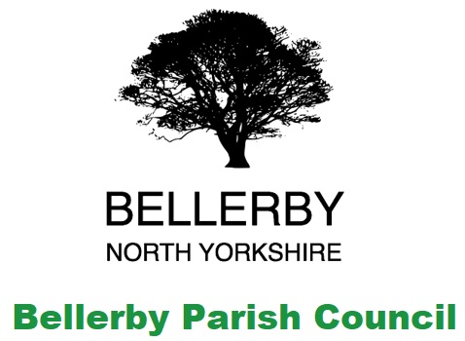**Bellerby Parish Council**

The Annual Meeting of Bellerby Parish was held virtually on

**Monday 3rd May 2021 at 7:30pm**

The meeting was attended by:

The clerk Lynn Watkinson.

Councillors Hutchinson, Chilton, Dilworth, Scriven & Travell.

Chairman of the Memorial Hall & Bellerby Educational Foundation Trust

Two members of the public

*An* ***Annual Parish Meeting*** *consists of the local government electors of a* ***parish*** *and the purpose of the* ***meeting*** *is to discuss* ***parish*** *affairs.*

1. To receive the annual report of the Parish Council from the Chairman

***Copy attached***

1. To receive a report on the ongoing Parish Council projects in the parish

***Copy attached***

1. To receive an annual report from the Memorial Hall Chairman

***Copy attached***

1. To receive an update from the Playing Field committee

***Copy attached***

1. To discuss any items raised by the residents of Bellerby

A resident asked why there was no report from the Open Gardens Committee. It was noted that they along with all the other village groups had been invited but nothing had been received

6. Closing comments from the Chairman

The Chairman thanked the Chairman of the Memorial Hall & Bellerby Educational Foundation Trust for his reports and the members of the public for attending

Meeting closed: 19:50